QUES 1

SELECT * FROM Employee WHERE LEAVES=(SELECT MAX(LEAVES) FROM Employee)

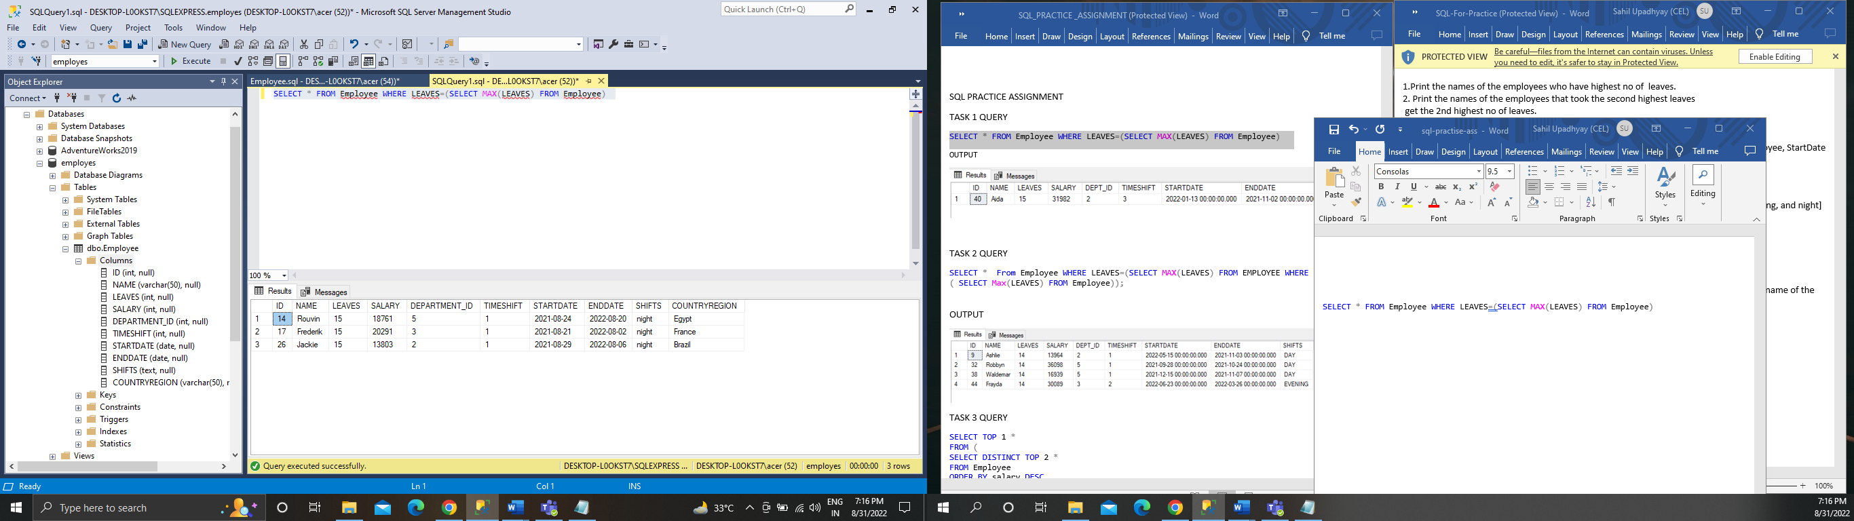

QUES 2

SELECT * From Employee WHERE LEAVES=(SELECT MAX(LEAVES) FROM EMPLOYEE WHERE LEAVES < ( SELECT Max(LEAVES) FROM Employee))

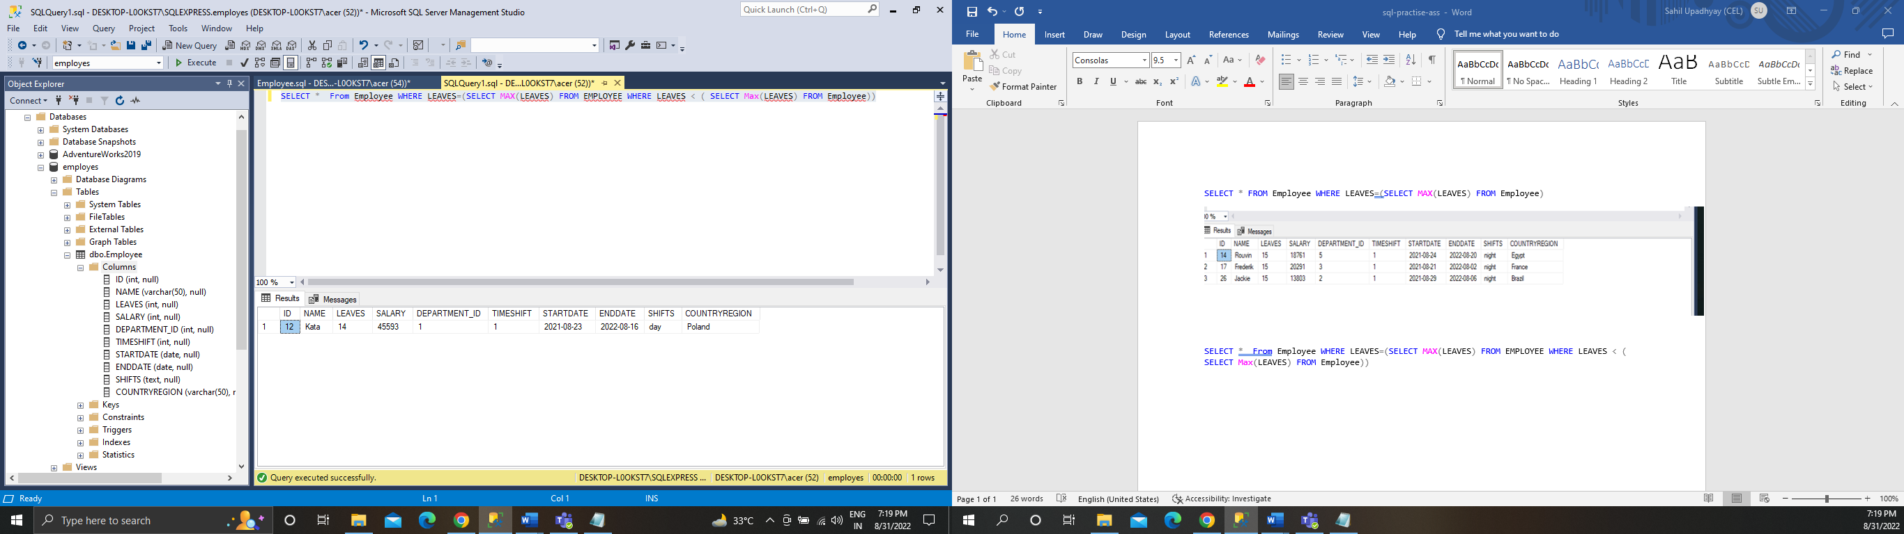

QUES 3

select top 1 Salary from

(

select distinct top 2 Salary as Salary from Employee order by Salary desc

) as result

order by Salary

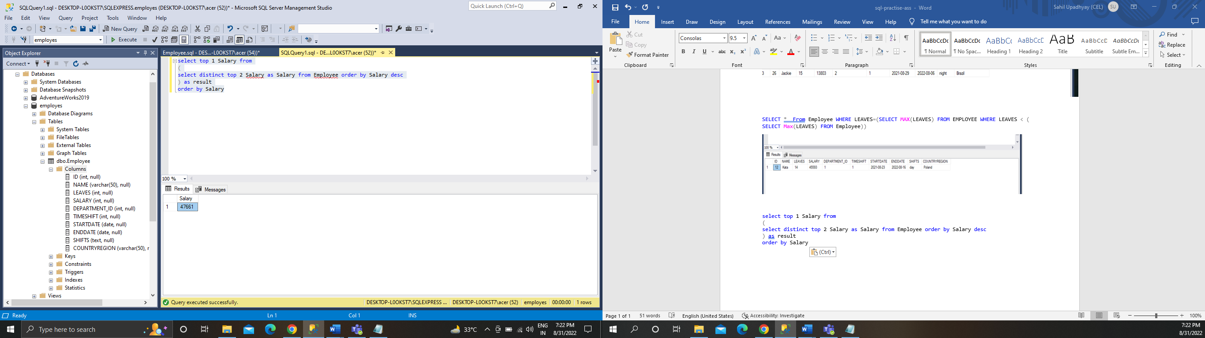

QUES 4

SELECT ID,

D.DEPARTMENT_NAME,

E.NAME,

E.STARTDATE,

E.ENDDATE

FROM Employee E INNER JOIN Department D ON E.DEPARTMENT_ID = D.DEPARTMENT_ID

ORDER BY NAME,STARTDATE ASC

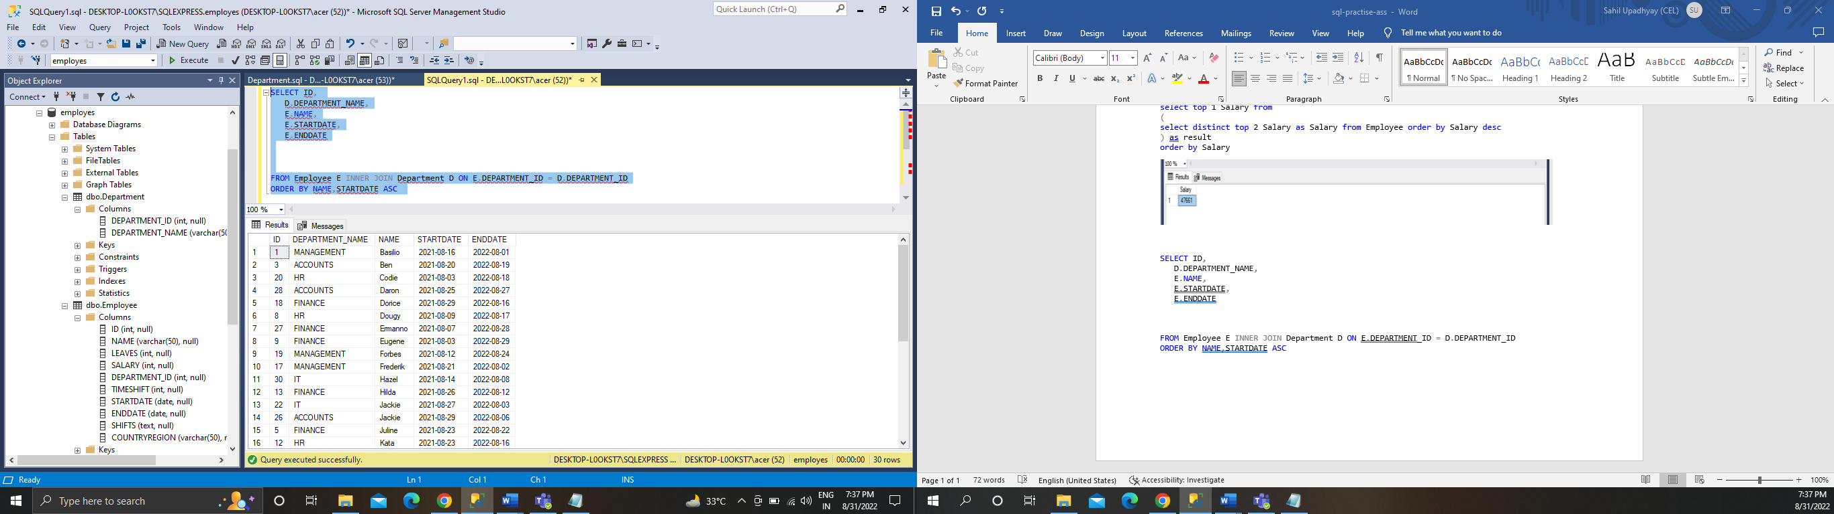

QUES 5

SELECT Employee.NAME,SecondDepartment.EMPID,COUNT(SecondDepartment.EMPID) AS TOTAL_DEPARTMENT

FROM Employee

INNER JOIN SecondDepartment

ON ID = SecondDepartment.EMPID

GROUP BY SecondDepartment.EMPID,Employee.NAME

HAVING COUNT(*) > 1

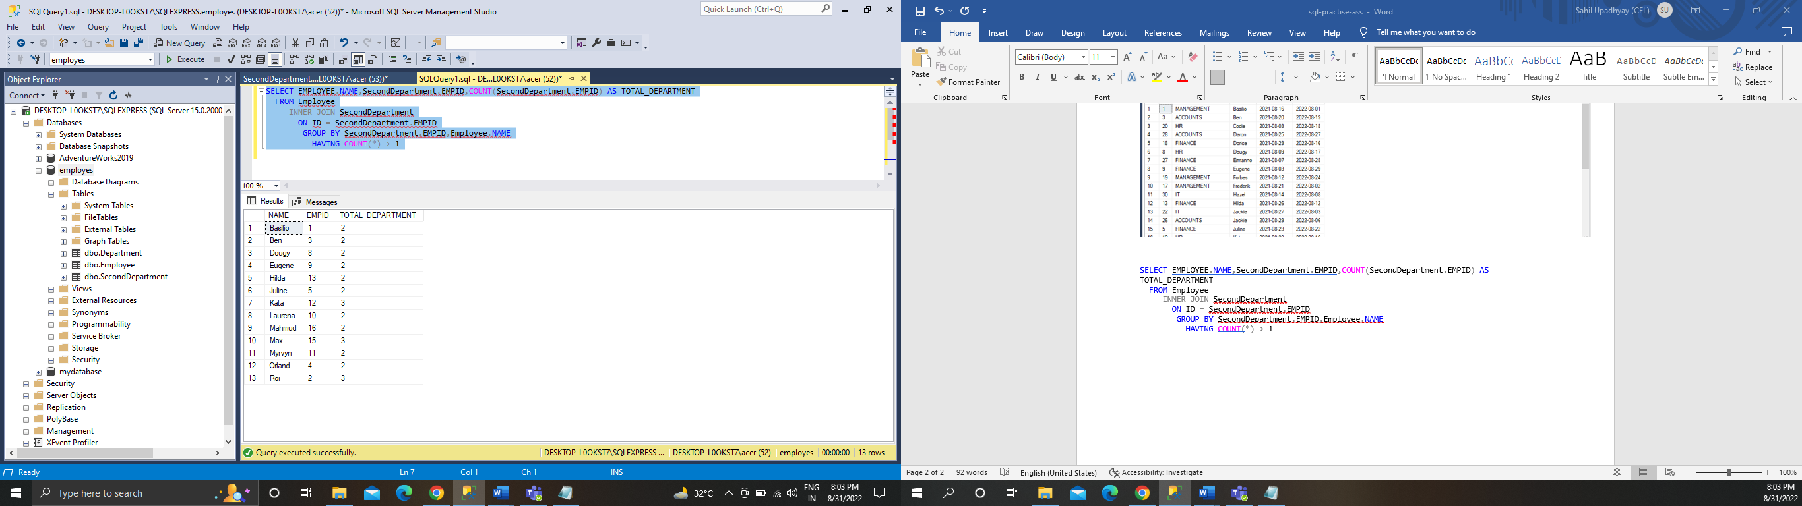

QUES 6

SELECT COUNT(*) AS NO_DEPARTMENT FROM Employee WHERE DEPartment_ID=0

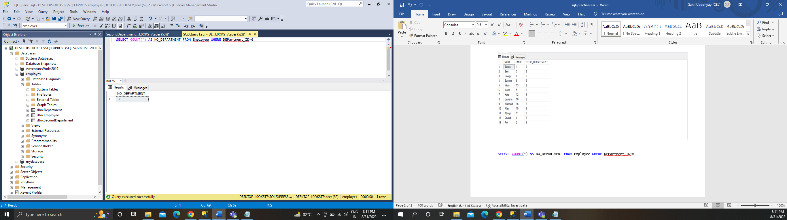

QUES 7

SELECT SHIFTS, COUNT(*) AS EMPLOYEES

FROM Employee

GROUP BY SHIFTS

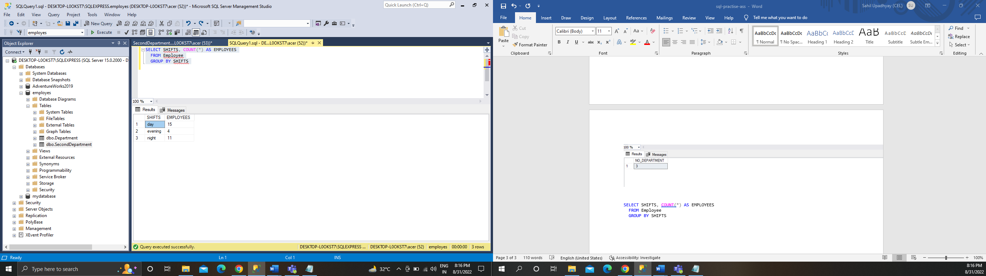

QUES 8

SELECT countryregion,COUNT(*) AS countryregioncount

FROM EMPLOYEE

GROUP BY COUNTRYREGION

ORDER BY countryregioncount

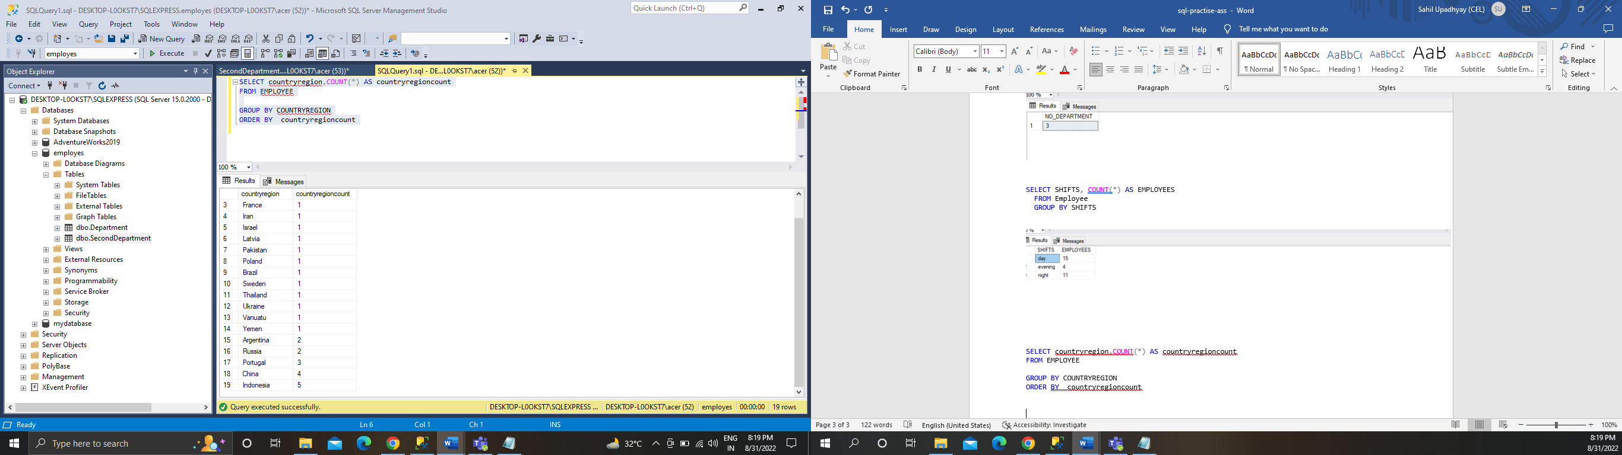

QUES 9

SELECT TOP(1) countryregion,COUNT(*) AS countryregioncount

FROM EMPLOYEE

GROUP BY COUNTRYREGION

ORDER BY countryregioncount DESC

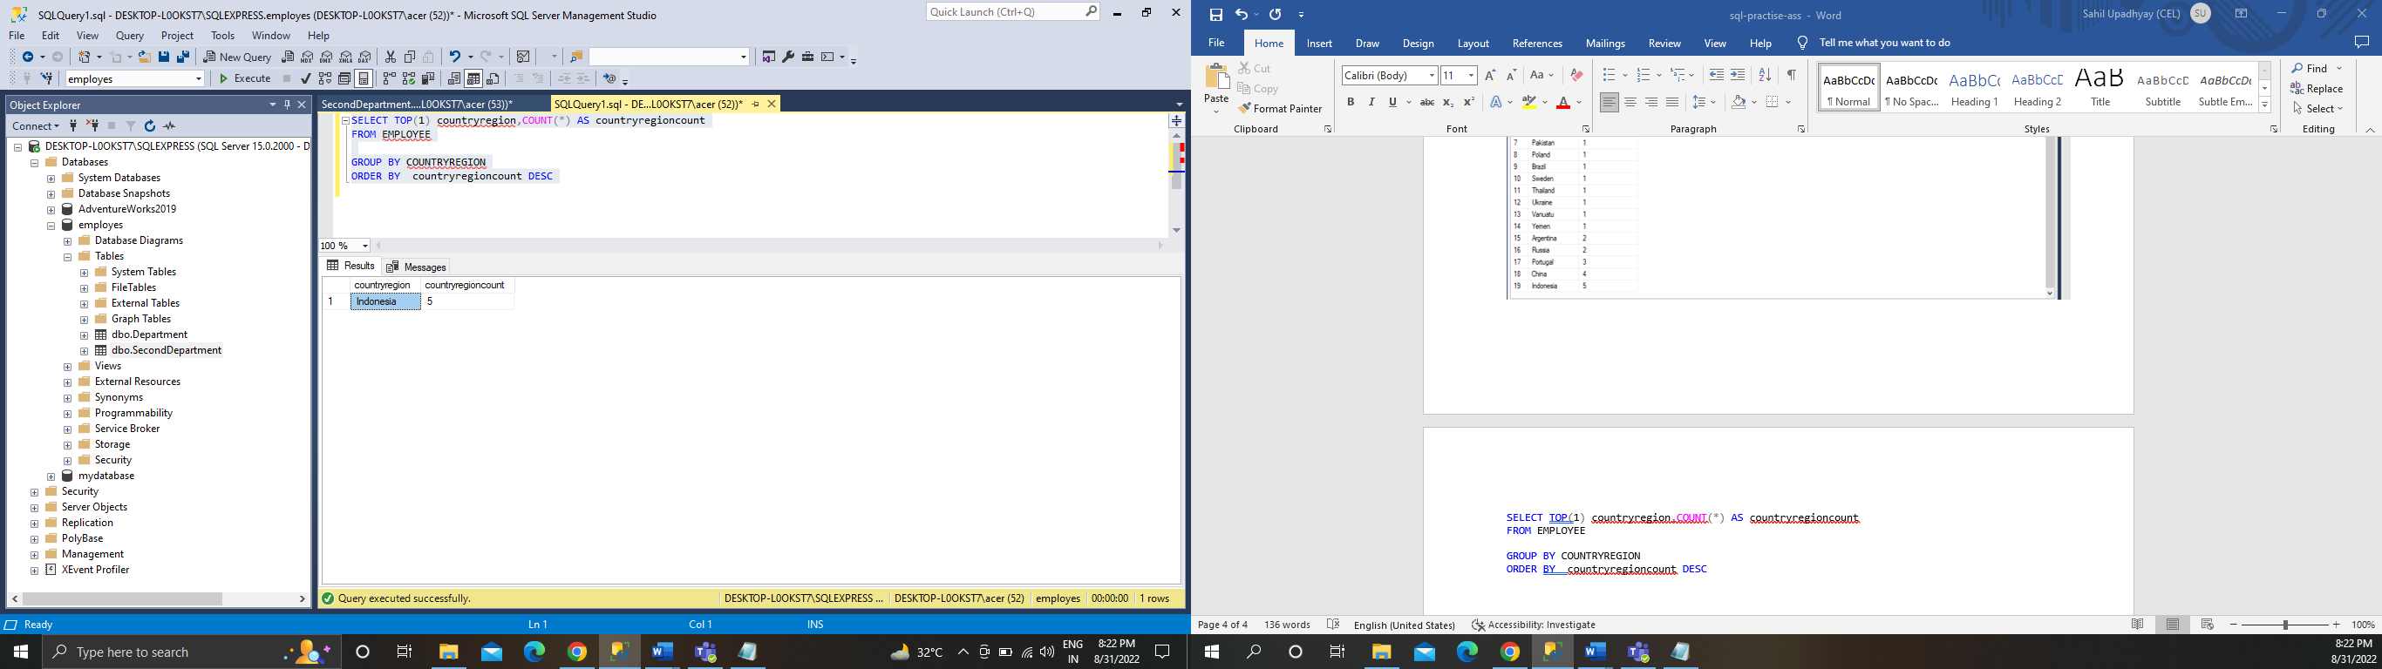

QUES 10

SELECT FIRST_NAME,LAST_NAME ,CONCAT(STREET , '-', REGION , '-' ,POSTALCODE , '-' ,COUNTRY ) AS ADDRESSTYPE FROM ADDRESS

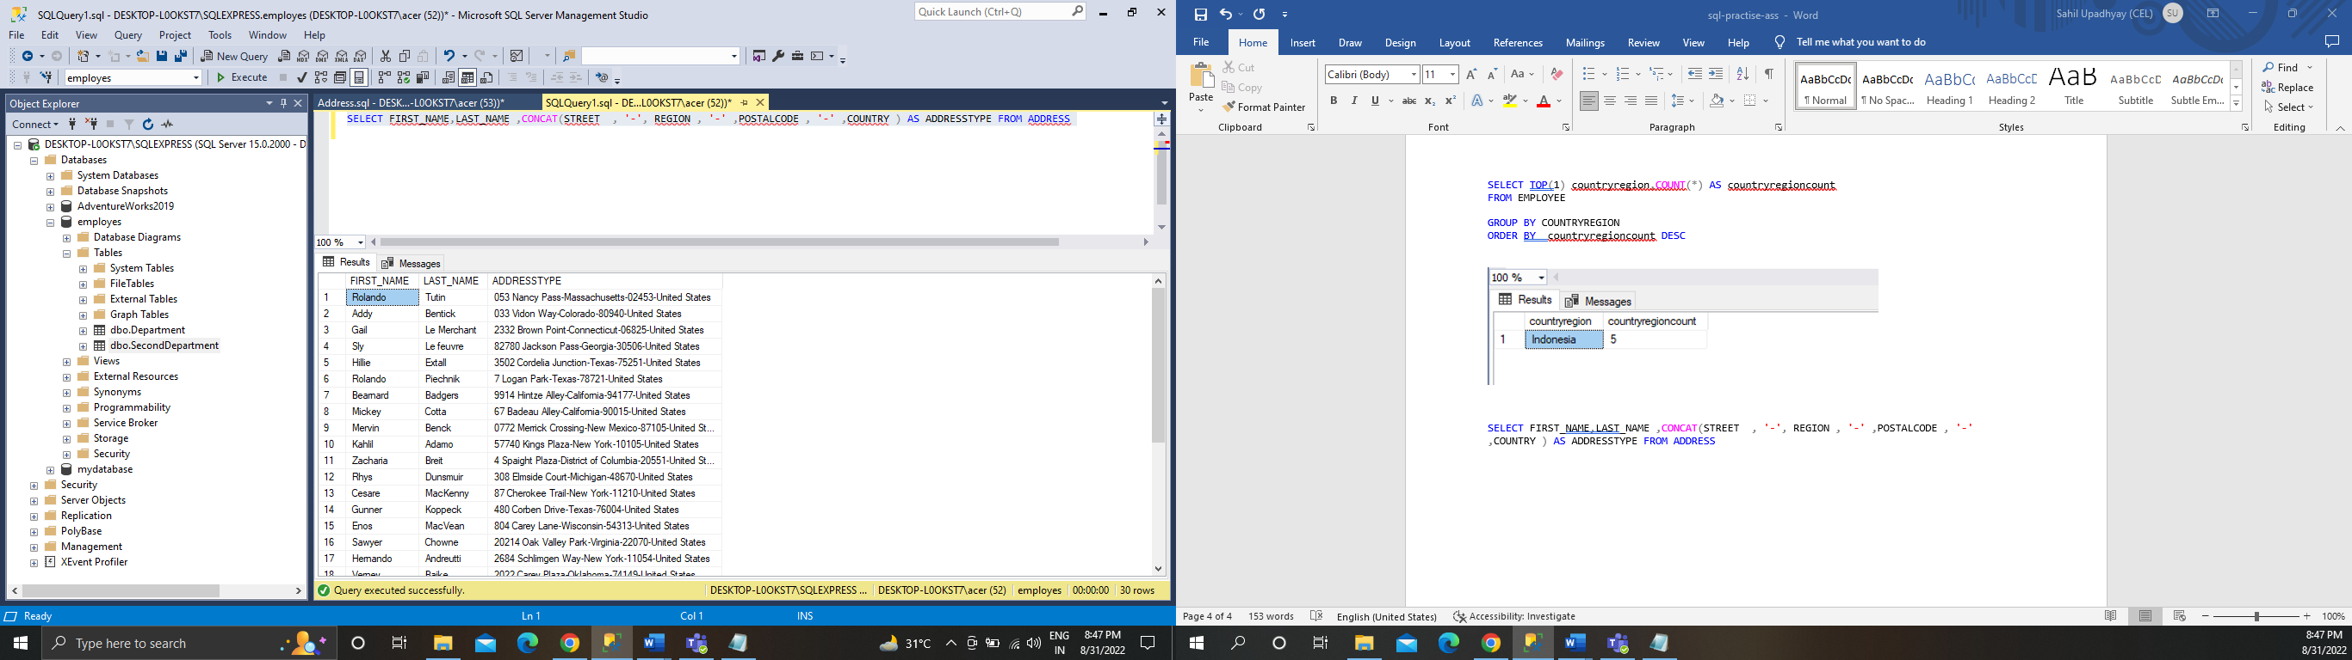

QUES 11

SELECT * FROM ADDRESS WHERE ADDRESSTYPE NOT IN ('WORK+SHIPPING')

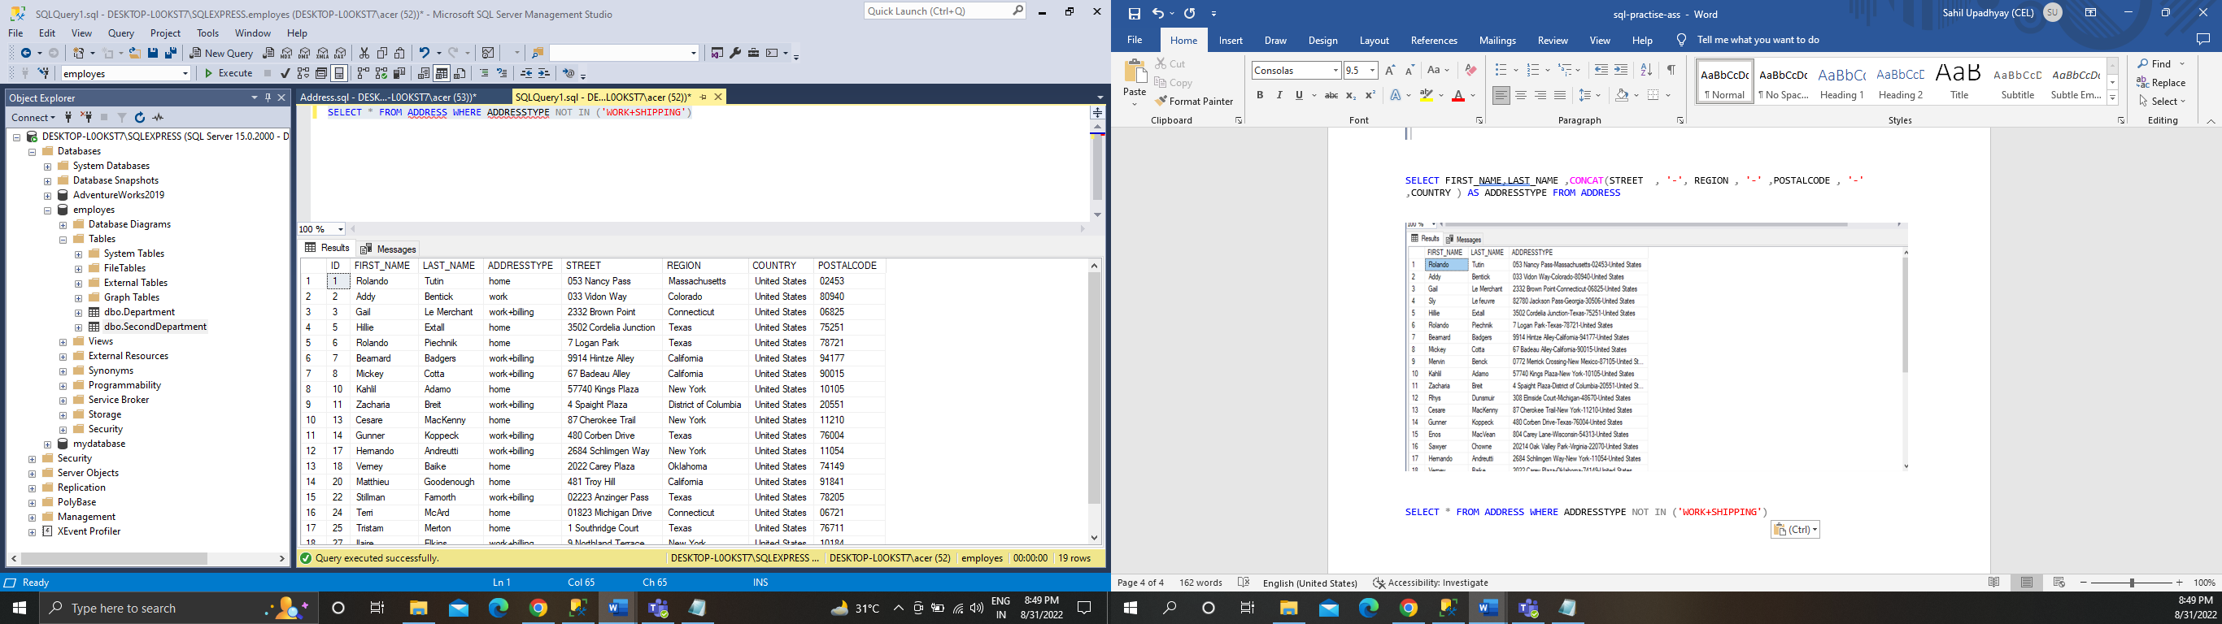

QUES 12

SELECT * FROM ADDRESS WHERE ADDRESSTYPE IN ('HOME+BILLING')

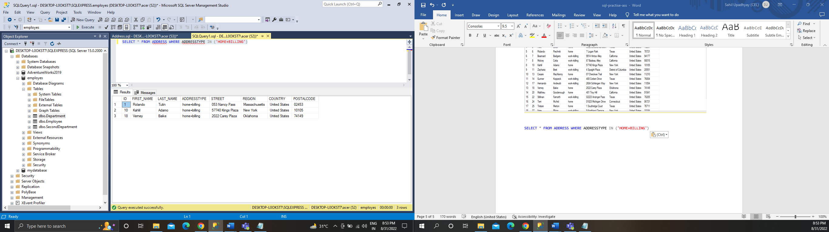

QUES 13

SELECT REGION, COUNT(REGION) AS TOTALEMPLOYEE FROM ADDRESS WHERE REGION ='TEXAS' GROUP BY REGION

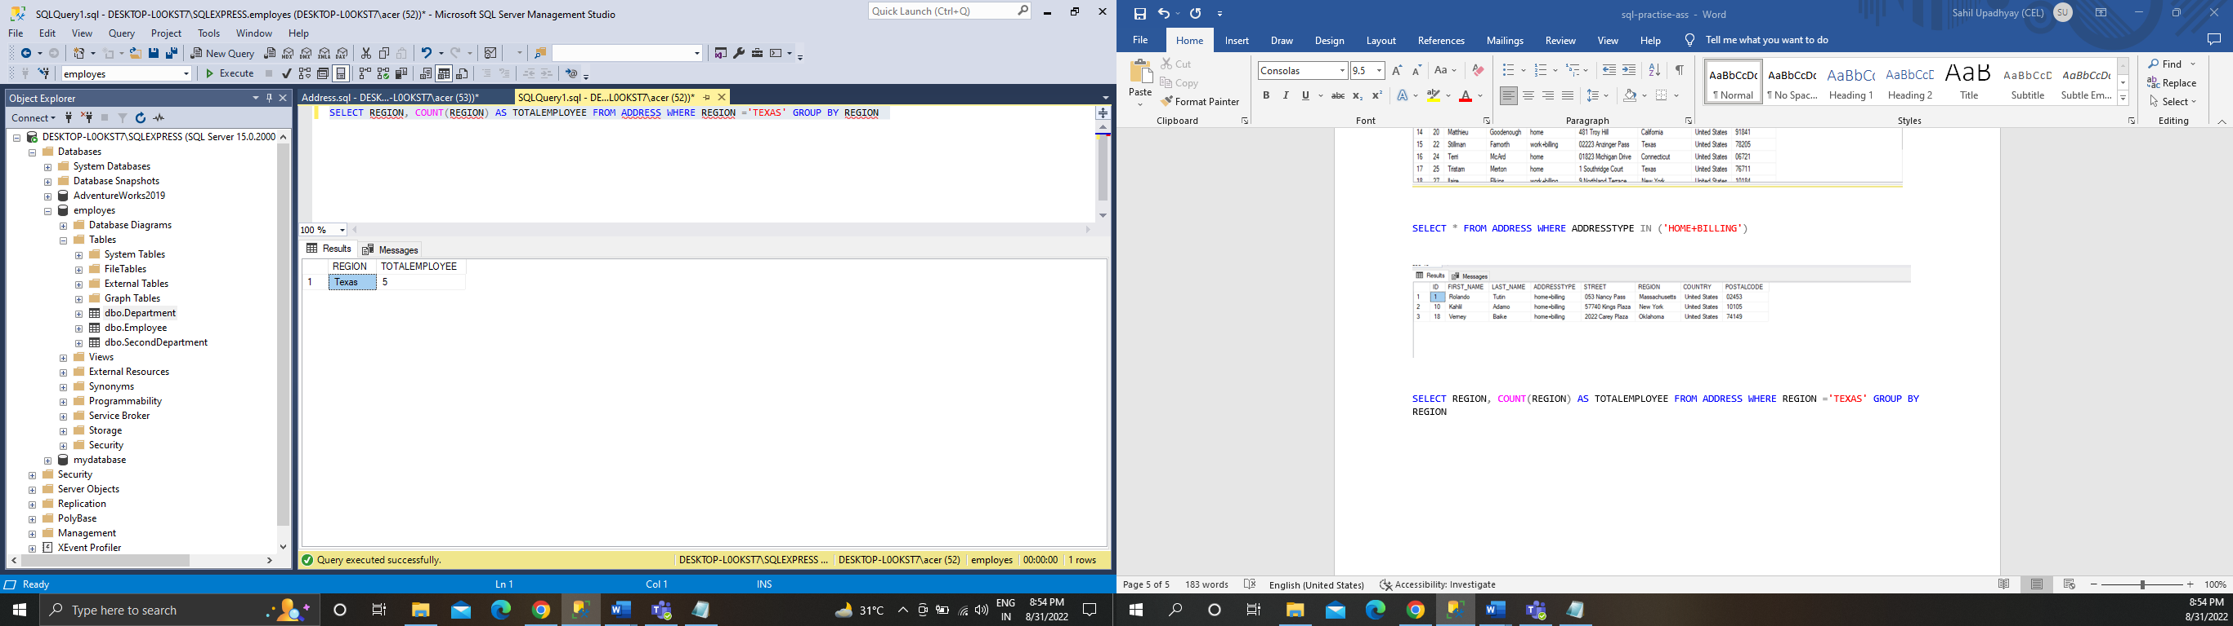

QUES 14

SELECT C.C_ID,C.C_NAME,P.P_ID,P.P_NAME,P.PRICE,O.QUANTITY,P.PRICE*O.QUANTITY AS TOTALSALE FROM CUSTOMER C INNER JOIN ORDERT O ON C.C_ID=O.C_ID INNER JOIN PRODUCT P ON O.P_ID=P.P_ID

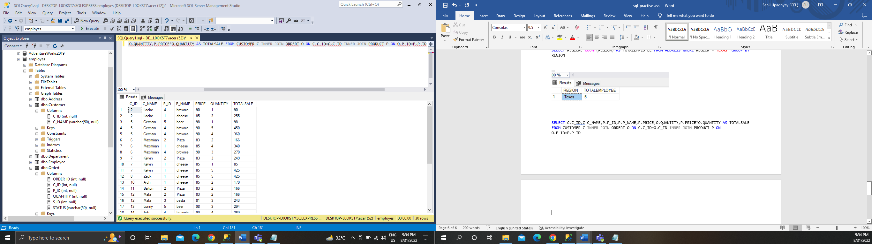

QUES 15

SELECT TOP(1) S.SP_NAME, COUNT(O.S_ID) AS HIGHESTSALE from sale S INNER JOIN

ORDERT O ON S.S_ID=O.S_ID

GROUP BY O.S_ID,S.SP_NAME ORDER BY HIGHESTSALE DESC

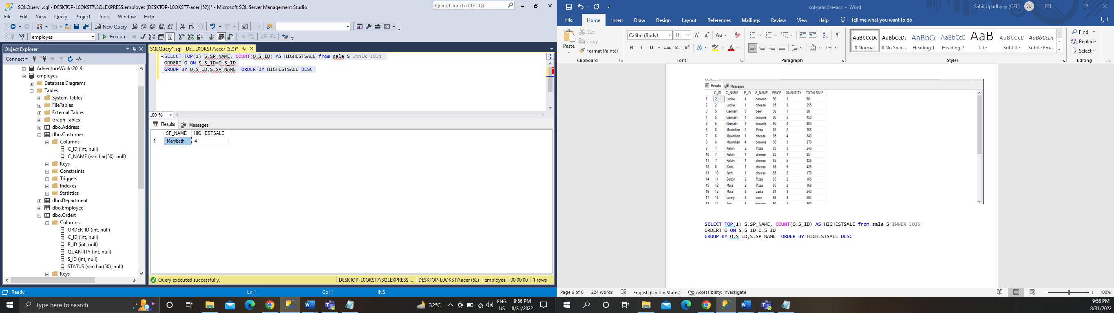

QUES 16

SELECT STATUS , COUNT(STATUS) AS COMPARISON FROM sale GROUP BY STATUS

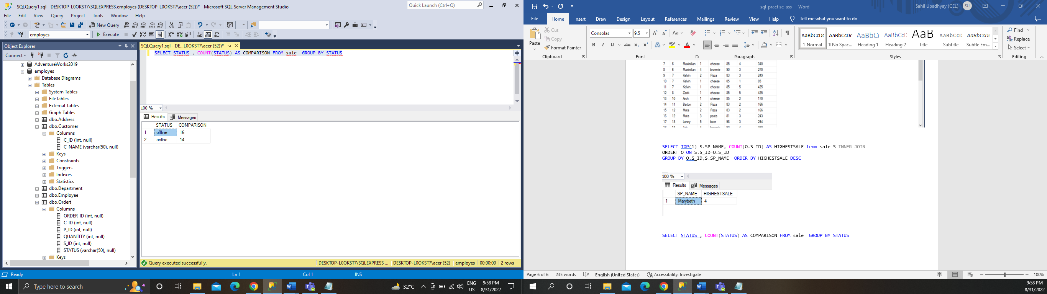

QUES 17

SELECT STATUS,COUNT(STATUS) AS UPDATES FROM ORDERT GROUP BY STATUS

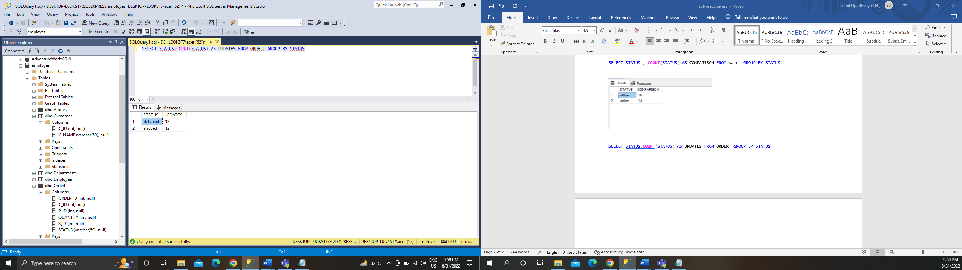

QUES 18

SELECT O.P_ID ,P.P_NAME, COUNT(O.P_ID) AS CUSTOMERS FROM ORDERT O INNER JOIN PRODUCT P ON O.P_ID=P.P_ID GROUP BY O.P_ID,P.P_NAME ORDER BY CUSTOMERS DESC

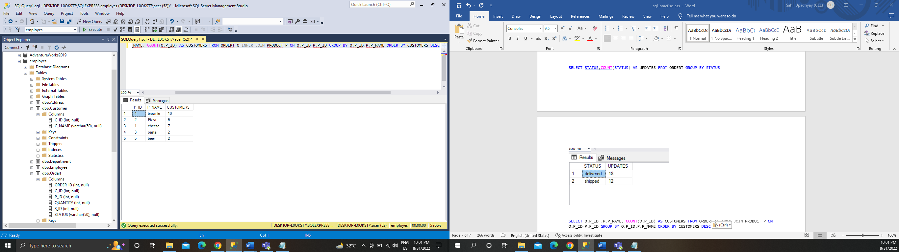

QUES 19

SELECT TOP(1) O.P_ID ,P.P_NAME AS POPULARPRODUCT, COUNT(O.P_ID) AS CUSTOMERS FROM ORDERT O INNER JOIN PRODUCT P ON O.P_ID=P.P_ID GROUP BY O.P_ID,P.P_NAME

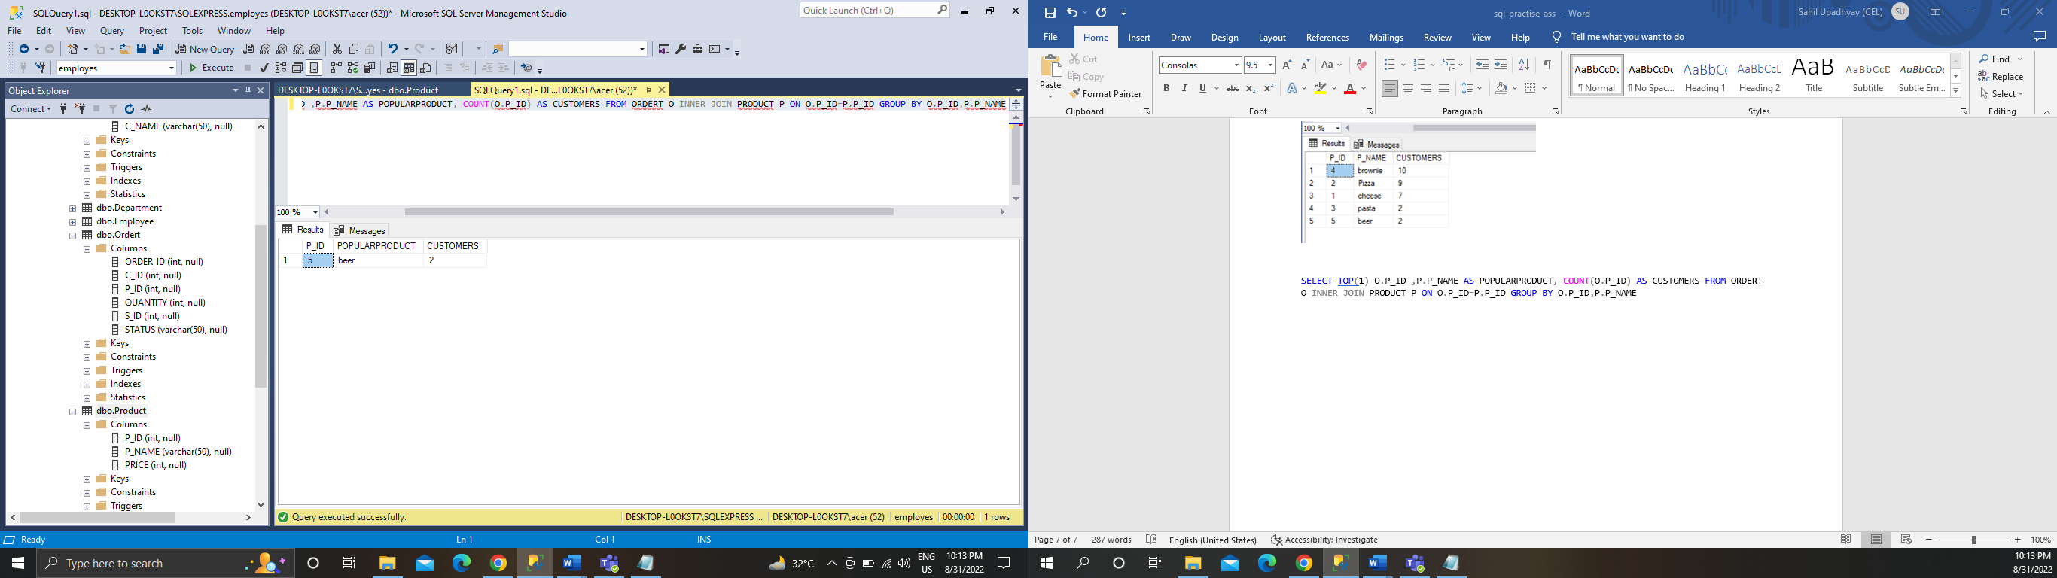

QUES 20

SELECT T.P_NAME,SUM(O.QUANTITY*T.PRICE) AS REVENUE FROM ORDERT O INNER JOIN PRODUCT T ON O.P_ID=T.P_ID GROUP BY T.P_NAME

